Experiment:6-DCL Commands – GRANT, REVOKE

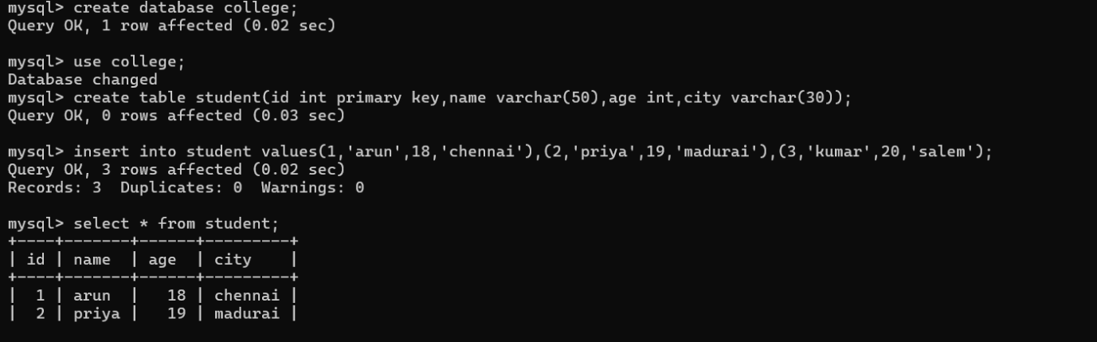

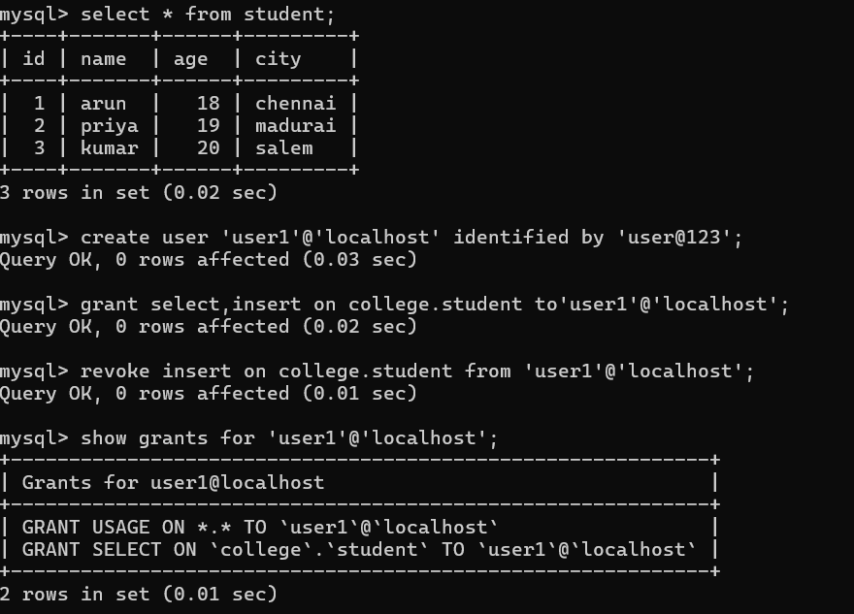

Experiment:7-SELECT with various clauses – WHERE, pattern matching

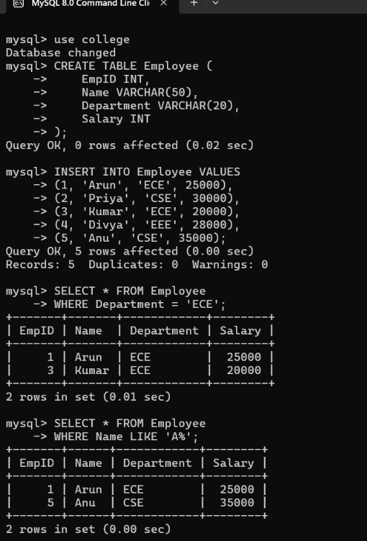

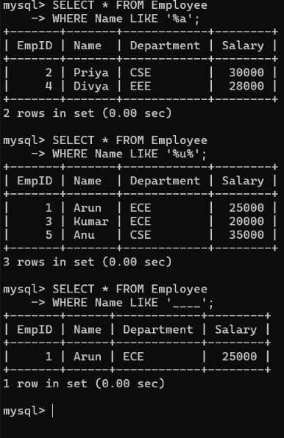

Experiment:8-SELECT with various clauses – BETWEEN, IN, Aggregate Function

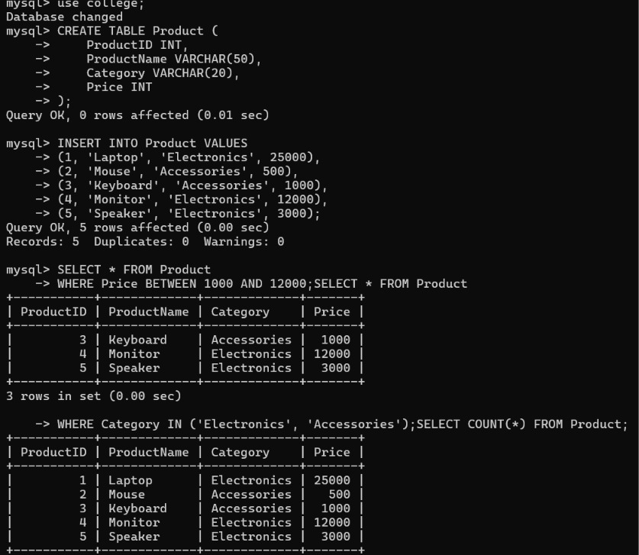

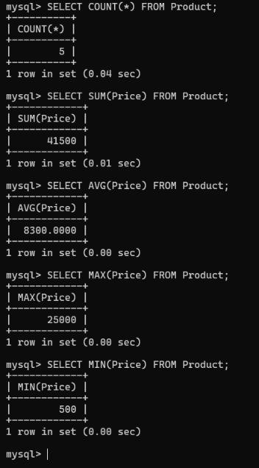

Experiment:9-SELECT with various clauses – GROUP BY, HAVING, ORDER BY
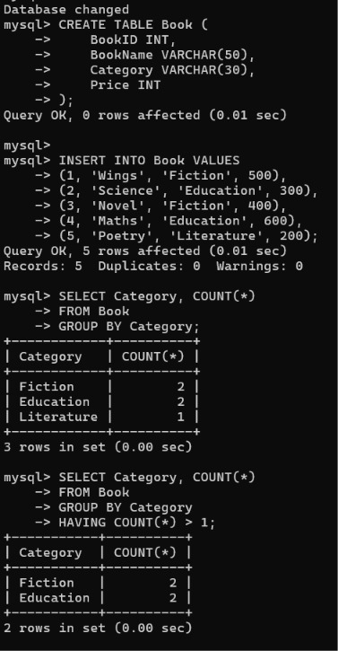

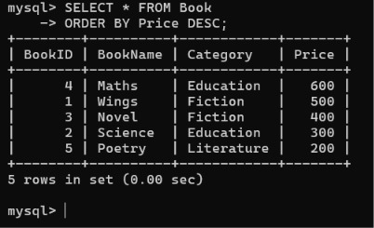

Experiment:10-Query with Sub Query& Correlated Query

